**Front-End UI/UX Mini Project**

**Project Title:** Movie Info Page

**Submitted by:**

* **Team members:** Thirisha Babu Velu

Aishwarya S

Tharika K

* **Roll Number:** 2460464

2460315

2460463

* **College E-mail id:** thirisha.babu@btech.christuniversity.in

aishwarya.s@btech.christuniversity.in

tharika.k@btech.christuniversity.in

**Course:** Front-End UI/UX Development

**Instructor Name:** Mr. Narendran

**Institution:** Christ University

**Date of Submission:**11.08.2025

**2.Abstract:**

* This project is about creating a simple and responsive recipe blog template using only HTML and CSS.
* The main goal is to design a web page that allows users to view and read different recipes in a clean and attractive layout. The template includes sections for recipe titles, ingredients, preparation steps, images.
* The core technologies used are HTML for content structure and CSS for styling and layout.
* The final result is a user-friendly, mobile-responsive recipe blog that can be used by food bloggers or cooking enthusiasts to share recipes online.

**3.Objectives:**

* Create a clean and organized layout for displaying recipes.
* Use HTML to structure different sections like ingredients, steps, and images.
* Apply CSS to enhance the design and make the page responsive.
* Make the template easy to read and visually appealing on all devices.

**4.Scope of the Project:**

* Focused solely on front-end design and layout.
* No JavaScript, backend, or dynamic data handling.
* Responsive design targeting desktop, tablet, and mobile devices.
* Built using only open-source tools and hand-coded HTML/CSS.
* Content example: Crème Brûlée recipe.

**5.Tools & Technologies Used:**

|  |  |
| --- | --- |
| **Tool/Technology** | **Purpose** |
| HTML5 | Markup for content and structure |
| CSS3 | Styling, layout, and responsiveness |
| VS Code | Code editor |
| Chrome DevTools | Inspecting elements, testing layout |

**6.HTML Structure Overview:**

* Used semantic tags: <header>, <nav>, <main>, <section>, <article>, <footer>.
* Header with title.
* Main content section displaying the Crème Brûlée recipe:

1. Ingredients list
2. Step-by-step preparation method
3. Optional image of the dessert

**7.CSS Styling Strategy:**

* Used external CSS file (style.css).
* Organized using clear comments and modular sections for readability and maintainability.
* Techniques used:

1. Flexbox and CSS Grid for responsive and structured layout.
2. Media Queries for adapting to different screen sizes.
3. CSS Variables for easy theme customization.
4. Smooth transitions for user interactions like button clicks or link hovers.
5. Mobile-first design approach to ensure optimal performance on small devices first.

**8.Key Features:**

|  |  |
| --- | --- |
| **Feature** | **Description** |
| Responsive Design | Adapts seamlessly across mobile, tablet, and desktop screens |
| Recipe Navigation | Sticky top nav with anchor links to Ingredients and Instructions sections |
| Recipe Card Layout | Structured with Grid and Flexbox, includes an image |
| Print-Friendly Styling | Print media styles allow clean printing of the recipe |
| Accessible Design | High contrast colour scheme and readable fonts |

**9.Challenges Faced & Solutions:**

|  |  |
| --- | --- |
| **Challenges** | **Solution** |
| Image not scaling properly on small screens | Applied max-width: 500px and height: 100% to ensure responsive image scaling |
| Misaligned sections on mobile view | Used media queries to adjust Flex/Grid layout for smaller screens |
| Recipe text too long for mobile | Applied padding, increased line height, and adjusted font size |

**10.Outcome:**

* Developed a clean, structured, and visually appealing front-end recipe blog.
* Successfully displayed recipe details using only HTML and CSS.
* Gained deeper understanding of semantic HTML, responsive design, and layout systems.
* Gained deeper understanding of semantic HTML, responsive design, and layout systems.

**11.Future Enhancements:**

* Add JavaScript for dynamic recipe interactions.
* Implement animation effects for section transitions and button interactions.
* Connect to a backend to allow recipe submissions or user comments.
* Introduce a theme toggle option (light/dark mode) for improved user experience.

**12.Sample Code:**

**//index.html**

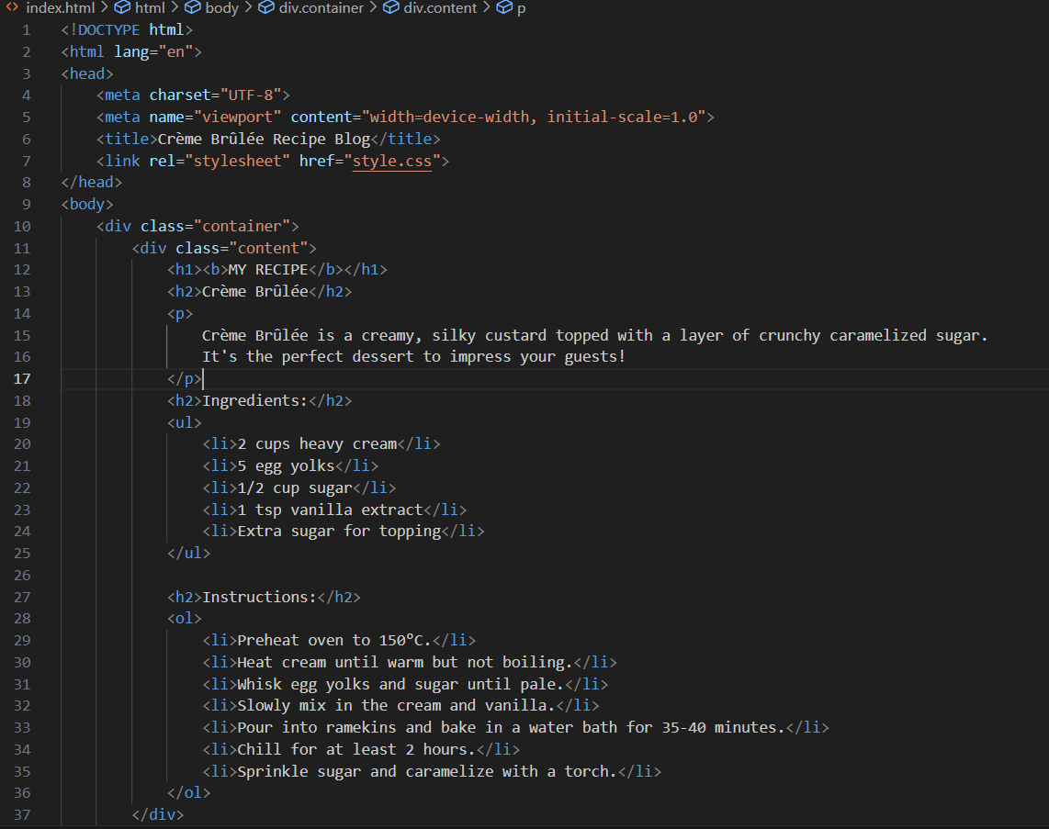

**//style.css**

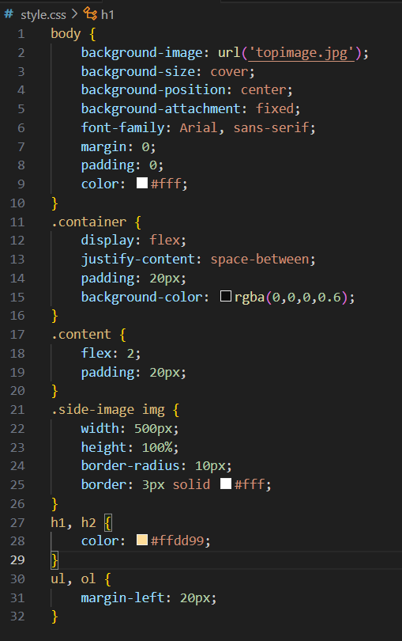

**13.Screenshots of Final Output:**

* Output as seen on laptop

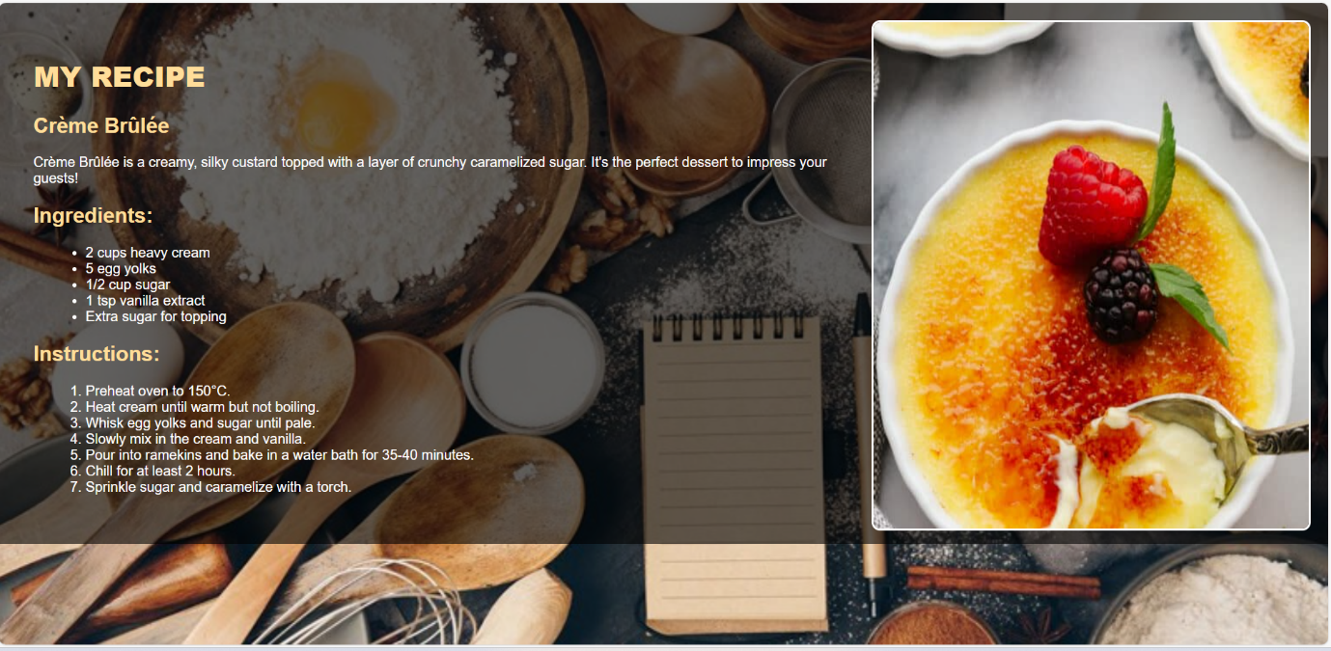

* Output as seen on mobile phone

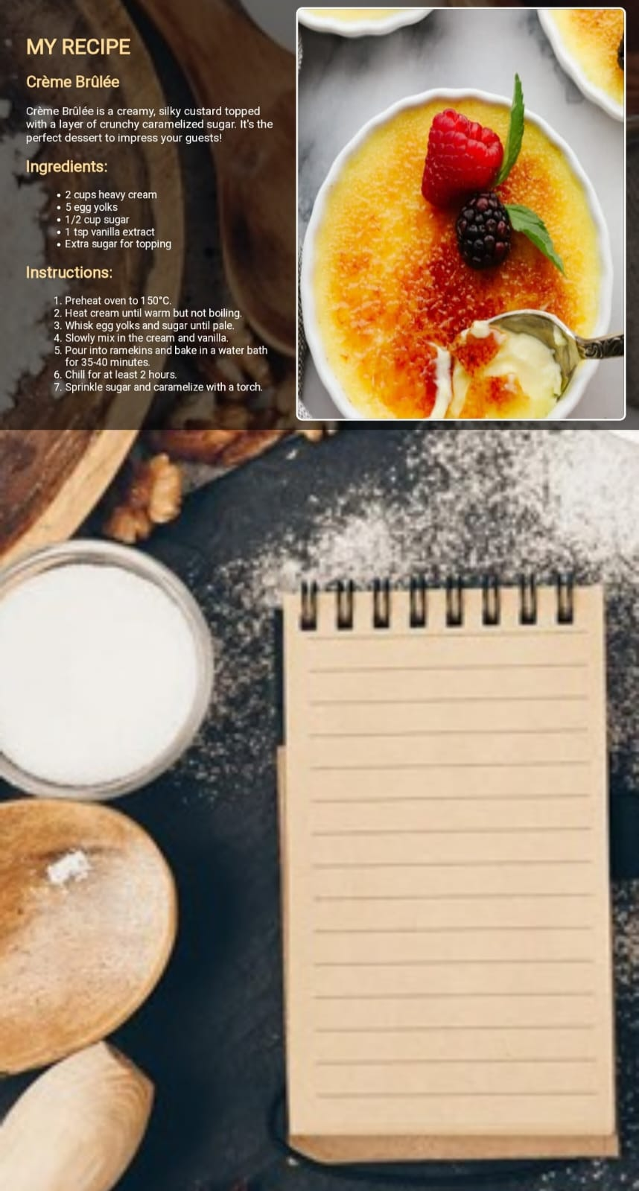

**14.Conclusion:**

* The Crème Brûlée recipe blog template was created using only HTML and CSS to build a simple, clean, and responsive webpage.
* It shows how front-end technologies can be used to design a recipe layout that looks good on all devices.
* This mini project helped in understanding the basics of web structure, styling, and responsive design.

**15.References:**

* L&T LMS: https://learn.lntedutech.com/Landing/MyCourse